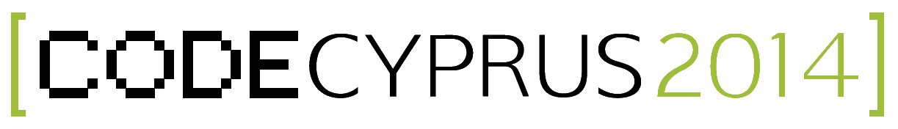

**Code Cyprus 2014 - Press Release (english)**

Pyla, 2014-02-20

**Inspiring High School Students to Take an Interest in Computer Science**

**The Project *Code Cyprus 2014* on Inspiring High School Students to Take an Interest in Coding and Entrepreneurship was Launched on Dec. 1, 2013**

The Code Cyprus 2014 project organizes an event where high school students are invited to participate, learn, win prizes, and have fun. The event aims at educating students about the beauty and value of coding, and its rich potential for entrepreneurship. It has received funding from the *Cyprus Fulbright Commission*, under the Alumni Small Grants scheme, and from *UCLan Cyprus*.

The event will take place on Saturday, March 8th, 2014 at the UCLan Cyprus campus in Pyla. The program starts at 8:30 a.m. with registration and ends at 3:30 p.m. with the prizes ceremony. The highlights of the event are:

* At registration, all the participantswill receive a welcome package that includes a commemorading t-shirt.
* During the event, the students will be tutored to the basic concepts of programming by building a fun mobile game. A number of programming books will be offered as prizes.
* The main highlight of the event will be a Treasure Hunt competition, where students will follow hints shown on their Android smart-phone to get to the treasure. The first three teams will win Pebble smartwatches.
* After lunch, the Startup Kids documentary will be played in high definition telling the story behind some of the most popular software startups, like Dropbox, Vimeo, Soundcloud, etc.

For more information visit the project’s website <http://www.codecyprus.org>.

Contact:

Dr. Nearchos Paspallis

School of Sciences  
UCLan Cyprus

12-14 University Avenue  
CY-7080, Pyla (Cyprus)

T +357 24 4000

[npaspallis@uclan.ac.uk](mailto:npaspallis@uclan.ac.uk)